PANEL 1 — Entry / First Encounter
[Sketch box]
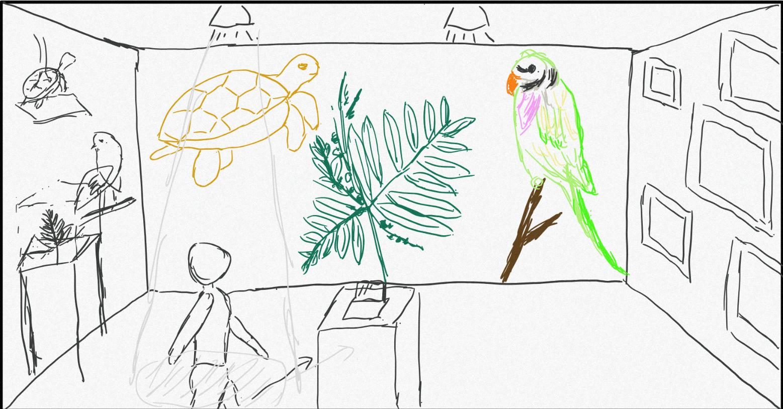Visitor Position: walking in
What the Visitor Sees First: On the large screen, rare or extinct Hainan endemic species — such as Zhao' er Mu, Hawksbill turtle, and Red-breasted Parakeet — are dissolving into particles.
Environment Notes: Light follows the visitor's footsteps, while audio plays an introduction to these plants and animals.
Background music (instrumental) will be played throughout; no further reminders will be given later.
Intended Feeling: Feeling awestruck, while also curious as to why they are "dissolving".

PANEL 2 — Orientation / Discovery (Understanding the Installation)
[ Sketch box ]
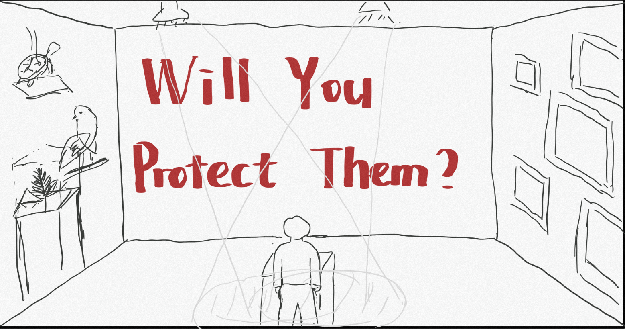Visitor Movement: pauses
Key Visual / Element: A red slogan appears on the screen: "Will you protect them?"
Sensory Details: As the visitor clicks, cracks spread across the screen accompanied by a shattering sound effect.
Intended Feeling: he visitor feels somewhat shocked and is led to reflect on whether they, too, have played a role as a "culprit" in environmental protection to some extent.

PANEL 3 — Interaction / Engagement
[ Sketch box ]
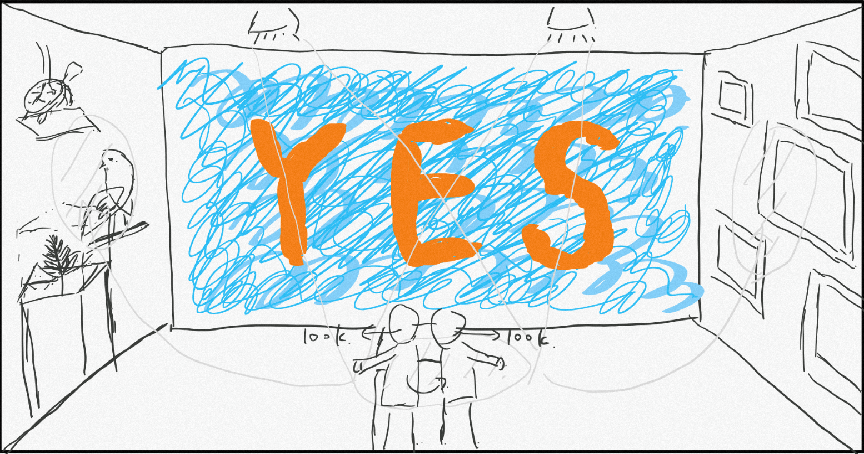Visitor Action: Use the mouse to write "YES" on the surging wave particles, which then merges with the waves (particle movement).
What Changes Because of the Visitor’s Interaction and Engagement: The light slowly moves from the visitor to the walls on both sides. The visitor notices the wildlife photos and specimens on the walls and observes them carefully.
Time Spent Here: long
Intended Feeling: The visitor feels a certain sense of responsibility for environmental protection resting on their own shoulders.

PANEL 4 — Peak Moment
[ Sketch box ]
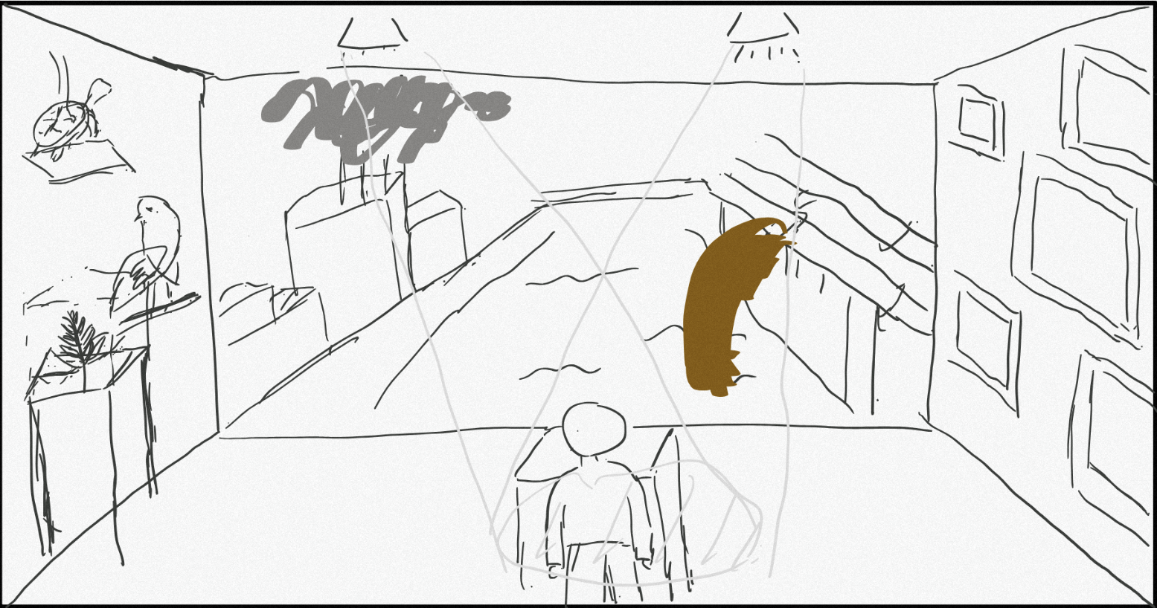What Changes Here: The screen transforms to show polluted water and thick smoke. The visitor clicks the mouse to "close off" or eliminate the particles of polluted water and thick smoke.
Main Emotional or Conceptual Impact: The visitor is actively engaged in the practical action of environmental protection. The previous scenes have already provided sufficient visual impact; now, by reducing pollution and seeing the tangible results, the effectiveness of environmental protection is concretely demonstrated.
Why This Is the Peak: Real action is the core of environmental protection.
Visitor Response You Hope For: The visitor feels that their actions are truly effective, strengthening their belief in actively participating in environmental protection in the future.

PANEL 5 — Exit / Reflection
[ Sketch box ]
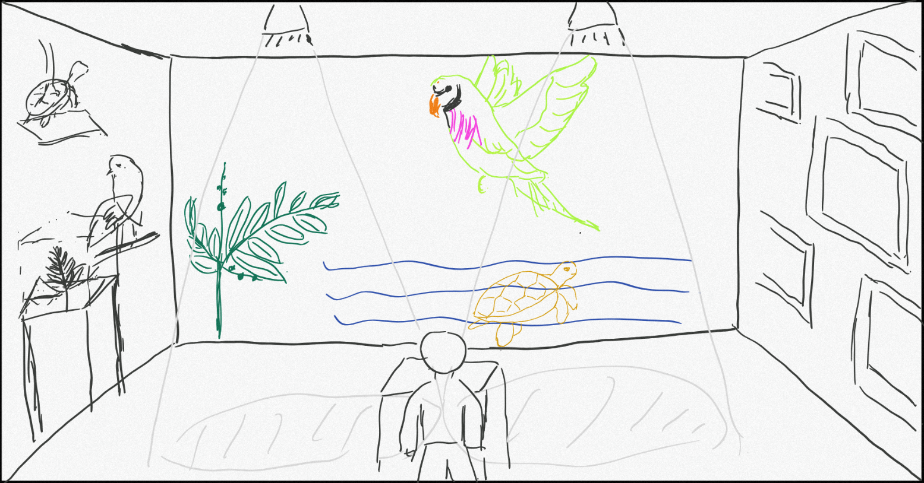How the Visitor Leaves the Space: The lights gradually brighten, evenly illuminating the entire exhibition space. After completing the final interaction, the visitor can leave along the wall displaying images of rare animals on the right.
Final Image / Sound / Animation: The particles on the screen gradually transform back into the plants and animals that were dissolving at the beginning, forming a closed loop that reinforces the idea that protecting the environment has positive effects — echoing the opening of the installation.
What You Want the Visitor to Remember: Many plants and animals are already in crisis or have gone extinct due to human activities, but it is never too late to take real action. As long as we act, there will be positive results.

Four-step method
Since the code consists of several distinct modules, due to space constraints, I will elaborate on the development process of one core section and briefly outline the rest.
Step1
As an artist based in Hainan, I intend to feature endemic endangered flora and fauna of Hainan to highlight the significance of environmental protection. These species are under severe threat and face imminent extinction. After deliberation and repeated trials, I have settled on the use of particles as my core artistic medium: the movement of particles symbolizes the vitality of living creatures, while their vanishing stands for the extinction of species, and so forth.
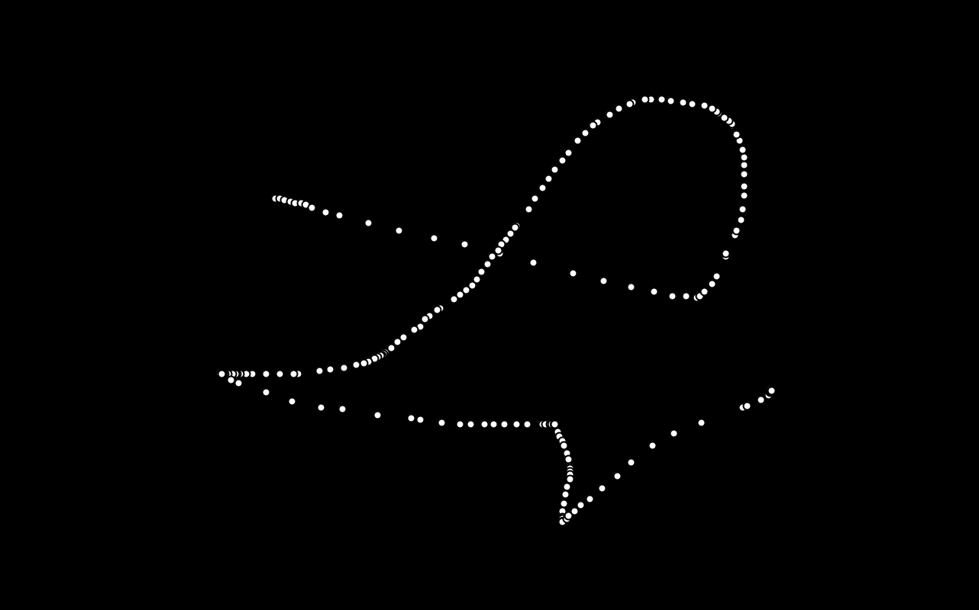
This image shows the particle effect generated by mouse movement from my initial experimental attempts.

Step2
Next, I explored transforming single particles into clusters, animating their movement, and programming them to follow set motion patterns to convey aesthetic value and conceptual meaning.

For another segment of the code workflow, I fed original photographs of endangered local species into an AI model, which then converted them into reference images rendered with a glass texture.
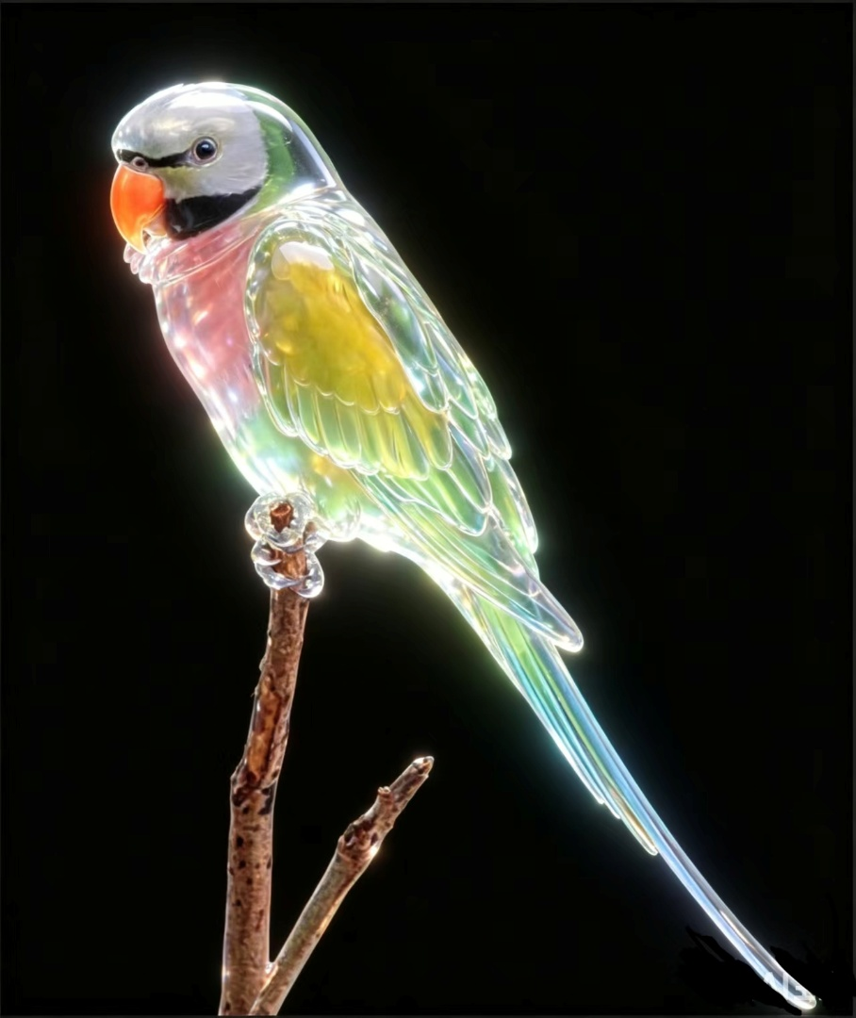
Step3
I then turned to designing audience interaction with the installation. My goal was to let visitors leave tangible imprints on the artwork through their interactions and create a striking visual impact. I designed the system so that particles within a specified range permanently turn orange when dragged with the mouse, symbolizing that our commitments and actions become an enduring part of nature.

Meanwhile, for another functional component, I added a click-triggered glass-cracking effect to the slogan. This design is intended to emphasize the profound impacts of human activities.
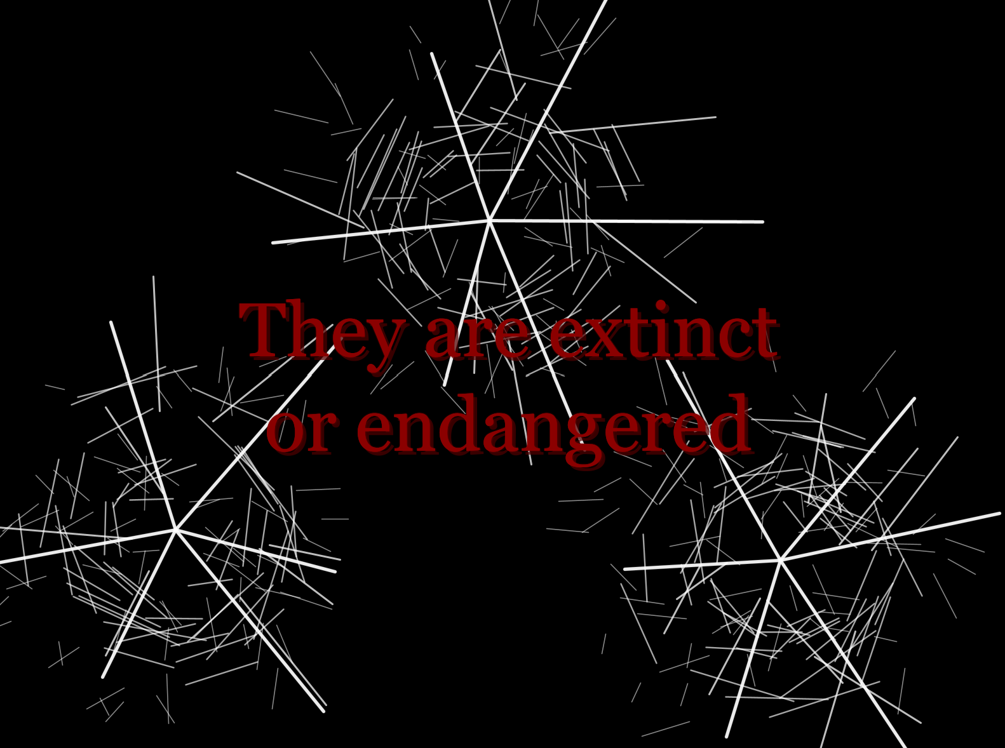
Step4
To enhance visitors’ experience, I incorporated a manual click-to-exit function for every stage of each installation. This boosts audience interactivity: viewers may skip ongoing animations and proceed to the next phase whenever they wish. Additionally, click sound effects were developed to deepen visitors’ impression and reinforce the core theme that every human action leaves an impact on nature. Lastly, I curated ambient lighting and background music for the exhibition space to craft a fully immersive viewing experience.



During the preparation of this Coursework I used doubao(豆包) and deepseek in order to
1. Convert real-life photos of endangered species into reference images with a glass texture.
2. After finalizing the artwork content, I consulted AI to identify optimal technical approaches and expressive styles for better visual appeal and interactivity.
3. When adding audio files, the sound library failed to play properly. With troubleshooting assistance from AI, I identified an incorrect output device setting and replaced it with the more compatible Minim library.
. After using this doubao(豆包) and deepseek, I take full responsibility for the content of the submission.”

